Narrative Nonfiction
100s - Philosophy and psychology
* In the DRHS Library collection
^ In the Henrico County Public Library collection
+ In either the HCPS or HCPL Sora collection - access via Clever (add the HCPL and set filter to ALL LIBRARIES)

Tags | Cover | Author | Title - linked to book description | * DRHS library  ^ Henrico County Public Library  + Sora
Nonfiction, Psychology, mental health, anxiety disorders |  | Richard Restak, M.D | Poe's Heart and the Mountain Climber  Exploring the Effect of Anxiety on Our Brains and Our Culture | *
Nonfiction, social media, influencers |  | Brian Boxer Wachler | Influenced: The Impact of Social Media on Our Perception | *
Nonfiction, business & economics, problem solving, computer science, cognitive science, algorithms | 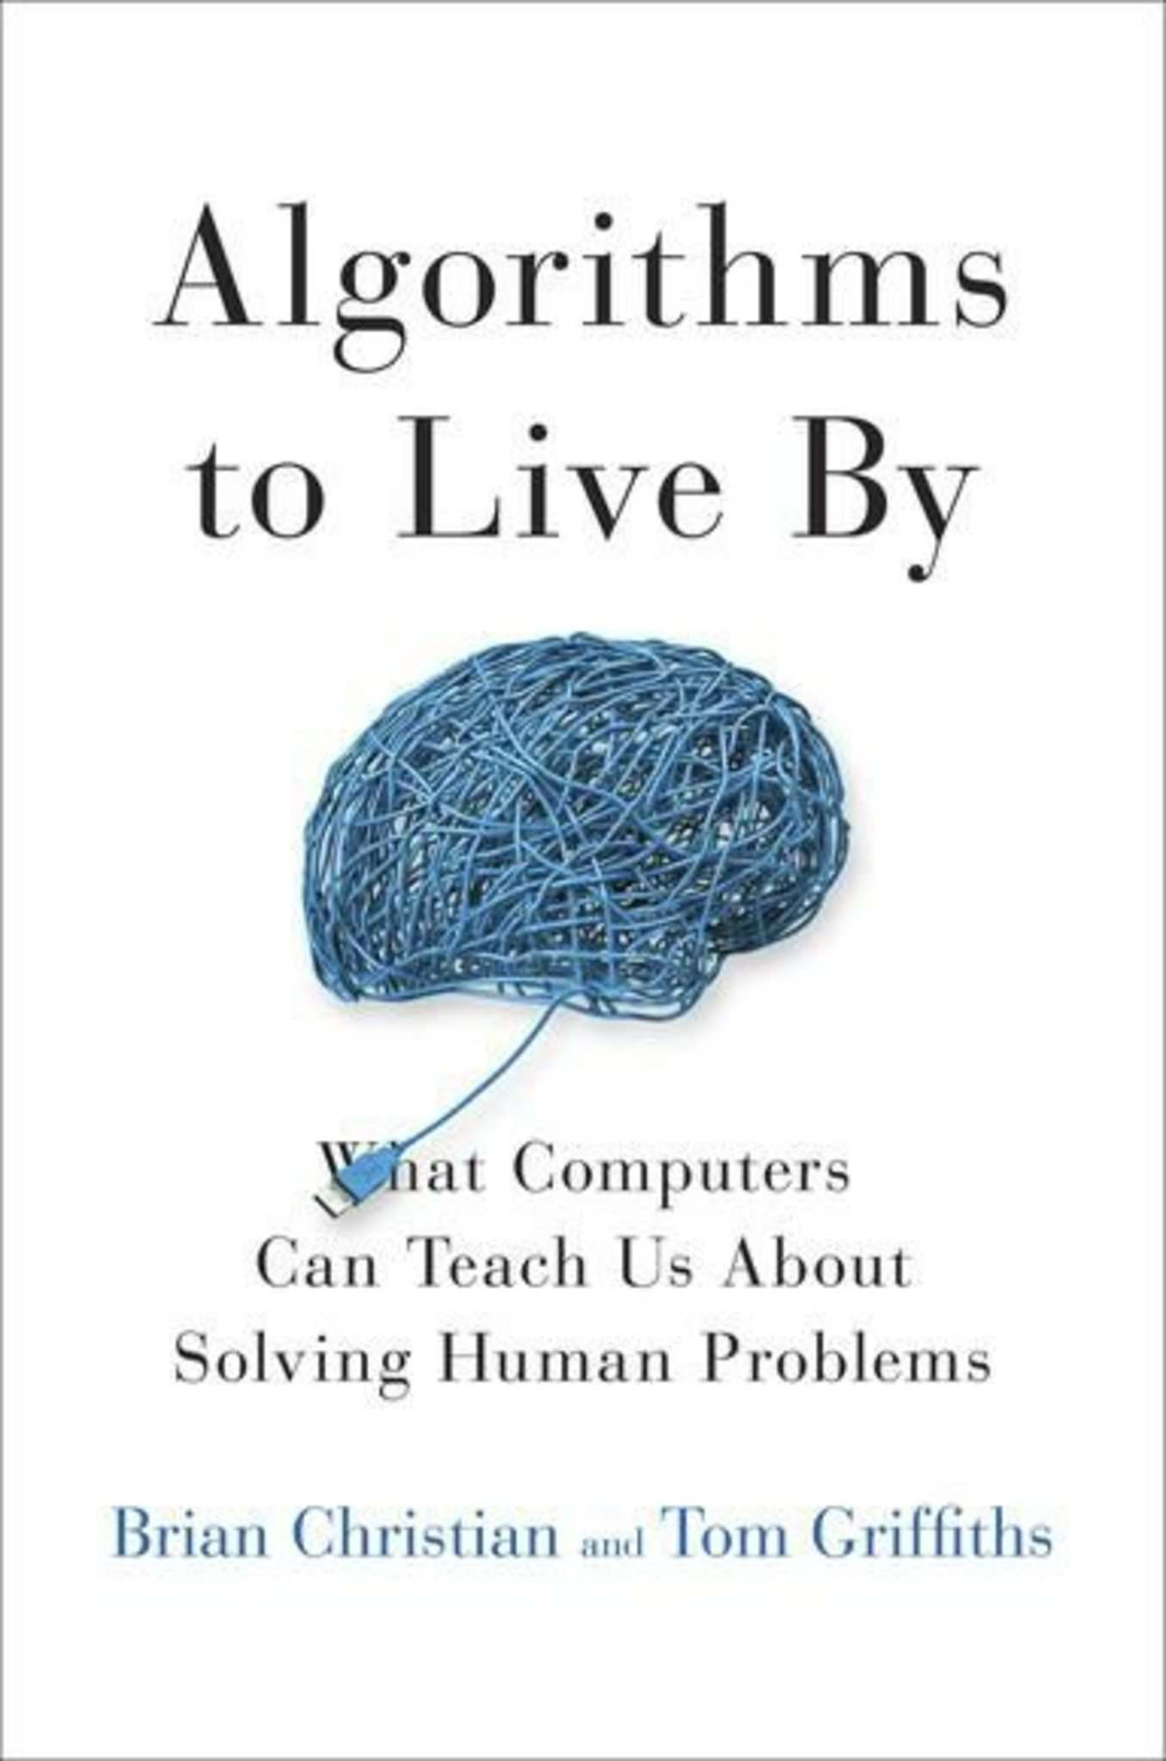 | Brian Christian, Tom Griffiths | Algorithms to Live By:  The Computer Science of Human Decisions | *  ^
Nonfiction, Psychology, life Sciences, Neuroscience, personal growth, memory improvement | 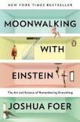 | Joshua Foer | Moonwalking with Einstein  The Art and Science of Remembering Everything | *  ^
Nonfiction, personal growth, social Psychology, critical thinking | 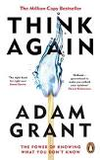 | Adam Grant | Think Again:  The Power of Knowing What You Don't Know | *  ^
Nonfiction, Psychology, problem solving | 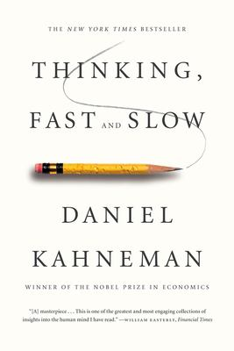 | Daniel Kahneman | Thinking, Fast and Slow | *  ^
Nonfiction,  Psychology,  Neuroscience,  Education | 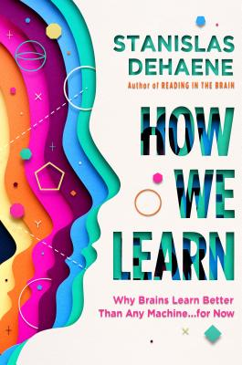 | Stanislas Dehaene | How We Learn: Why Brains Learn Better Than Any Machine . . . for Now | *
Nonfiction, personal growth | 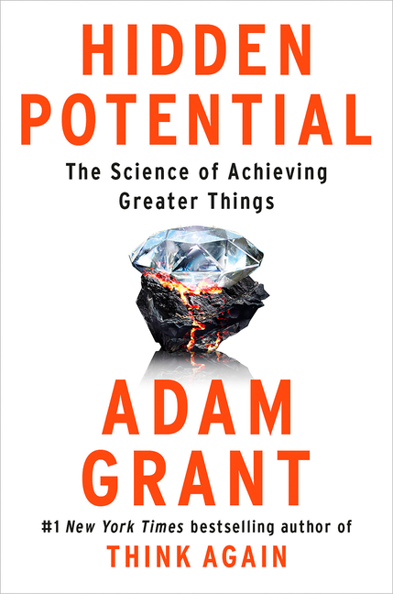 | Adam Grant | Hidden Potential: The Science of Achieving Greater Things | *  ^
Nonfiction, Psychology | 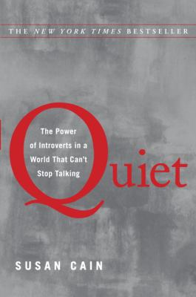 | Susan Cain | Quiet: The Power of Introverts in a World That Can't Stop Talking | *  ^
Nonfiction, success,  Psychology | 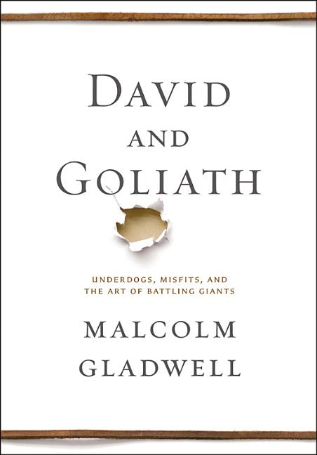 | Malcolm Gladwell | David and Goliath: Underdogs, Misfits, and the Art of Battling Giants | *  ^
Nonfiction, Psychology, Mental Health, Self-Help, Personal Growth, Happiness | 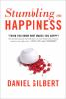 | Daniel Todd Gilbert | Stumbling on Happiness | *  ^
Nonfiction, personal growth, happiness, Philosophy | 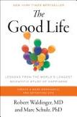 | Robert Waldinger, Marc Schulz | The Good Life: Lessons from the World's Longest Scientific Study of Happiness | *  ^
Nonfiction, personal growth, leadership, psychology, interpersonal relations, communication | 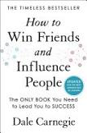 | Dale Carnegie | How to Win Friends and Influence People  Updated For the Next Generation of Leaders | *
Nonfiction, personal growth | 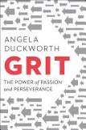 | Angela Duckworth | Grit: The Power of Passion and Perseverance | *  ^
Nonfiction, personal growth, psychology | 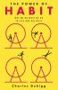 | Charles Duhigg | The Power of Habit: Why We Do What We Do in Life and Business | *  ^
Nonfiction, Philosophy | 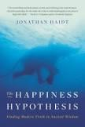 | Jonathan Haidt | The Happiness Hypothesis:  Finding Modern Truth in Ancient Wisdom | *  ^
Nonfiction, business, ethics, Philosophy, Sociology | 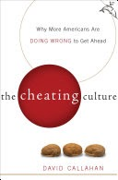 | David Callahan | The Cheating Culture: Why More Americans Are Doing Wrong to Get Ahead | *
Nonfiction, African Americans, medicine, public health, racial justice |  | Harriet A. Washington | Medical apartheid : the dark history of medical experimentation on Black Americans from colonial times to the present | *  ^
Nonfiction, health, diet & nutrition, Animal Rights |  | Gene Baur | Farm Sanctuary: Changing Hearts and Minds about Animals and Food | *
Nonfiction, history, Europe, Great Britain, nature, animal rights |  | Kathryn Shevelow | For the Love of Animals  The Rise of the Animal Protection Movement | *
Nonfiction, social Science, Psychology, personality | 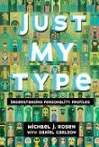 | Michael J. Rosen | Just My Type  Understanding Personality Profiles | *  ^
Nonfiction, history, science, human experimentation in medicine. |  | Vicki O. Wittenstein | For the Good of Mankind? The Shameful History of Human Medical Experimentation | *

